Eloise Freeland
‘Behavioural psychology can only reveal the effects of our upbringing, not our nature.’

Introduction
Behavioural psychology, on the premise of connecting behaviour to the human mind, is undoubtedly multifaceted by cause and not to be placed in a linear, deterministic perspective. Upbringing alone could not make up an individual, as it relies on caregiver intention and generosity in stimuli. if we were all products of our caregivers, there would be a bottleneck in how characteristics diversify; nature rectifies this problem effectively with its ungovernable and varied output of influence, removing the totalitarian control of environmental determinism.

An introduction to behavioural genetics
Behavioural genetics is a field of science that studies heritable factors and its effect on behaviour, merited by the decorum of contributors to acknowledge environmental factors as impactful on the individual and attempt to design studies that part nature and nurture. It was founded in the 19th century by Francis Galton but was discredited during World War II due to its association with eugenics. It ended up making a resurgence during the 20th century through twin and family studies and model organisms. Suggested by Turkheimer (1991), three laws outline behavioural genetics:
First law: All human behavioural traits are heritable
Second Law: The effect of being raised in the same family is smaller than the effect of genes
Third Law: A substantial portion of the variation in complex human behavioural traits is not accounted for by the effects of genes or families.
A fourth law was proposed by Chabris et al., (2015) which states:
A typical human behavioural trait is associated with very many genetic variants, each of which accounts for a very small percentage of the behavioural variability.
Each law is debatable, particularly the first two. Genetic approaches to behaviour are historically controversial and should be approached tactfully; for example, a child with a caregiver who committed an offense such as physical assault should therefore not be called a prospective abuser. If they did go on to become aggressive, there would be little way of knowing if it was due to upbringing, nature or imitation (social learning theory). Even in cases of estrangement, the continuity of abusive behaviour could likely be caused by cyclic patterns of negligent or unethical parenting and hereditary factors. This same logic is reflected in the argument of psychopaths being “born or made”, which will be addressed.

Genes in (atypical) behaviour
Finding candidate genes contributing to abnormal behavioural traits is meticulous and highly unlikely to be pathognomonic, however collected evidence is not worthy of discounting. Many named genes have been found to be correlated with the development of certain psychiatric disorders and invisible disabilities (e.g. SERT, COMT, CACNA1C, GABA, SHANK3). OCD has been implicated to be influenced by SERT and COMT genes which are related to serotonin transport and catabolising dopamine. The behaviours of an individual with OCD are characterised by anxiety induced compulsions such as cleaning or praying, which may be partly due to this biology.
It may be called a “genetic predisposition” and is often said if there is a familial history of an illness, emerging personally if there is a severe risk which can be the case for some disorders. For example, a study on schizophrenia in adult adoptees by Kety et al., (1976) showed those genetically related to the adoptees to also be schizophrenic whilst the adoptive relatives had a similar outcome to the controls in terms of schizophrenia. Upbringing here is weaker in significance and therefore is not always indicative of certain behaviours, especially those ensued by disorders. It also cannot explain the development of:
- De novo traits
- Neurodiversity
De novo means ‘anew’ and in genetics refers to a gene that is inherited from neither parent, it is either due to a mutation or emerging gene from a non-coding sequence . Upbringing is not involved in incidents like this, and de novo can affect behaviour depending on the affected gene(s), examples include de novo intellectual disability and de novo autism.
Neurodiversity refers to categorised disorders and disabilities that impact the way a person thinks, making information processing either impaired or atypical compared to the rest of the population. They are known to be majority genetic, but they can emerge because of pregnancy or perinatal complications, particularly autism spectrum disorder (ASD). Genes responsible for the development of autism have also been heavily speculated and appraised varyingly, finding many associated:
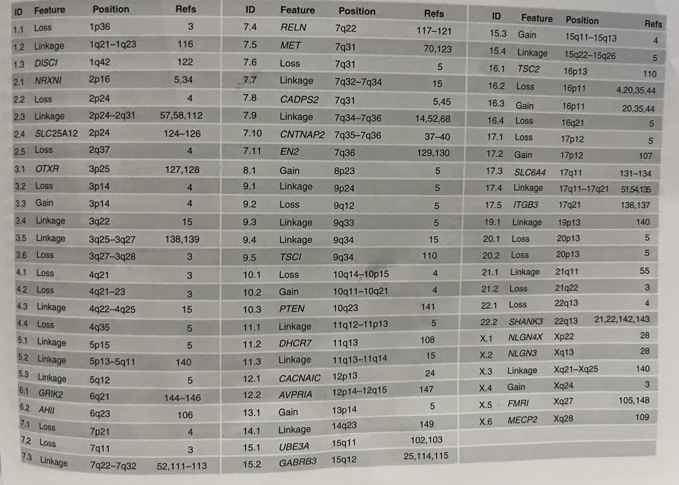
(2008, Abrahams et al.) Genes suggested to be associated with autism spectrum disorder (ASD). Malformations in chromosomes aswell as single nucleotide polymorphisms (SNPs) are said to contribute to the development of the disability.
A noticeable divarication of usual behaviour in young children can be a major signifier of autism. According to the DSM-V, behaviours involved in the diagnosis criteria of autism include repetitiveness, fixated interests, (behavioural) rigidness, abnormal paralinguistics, etc. which are overt symptoms. Nature determines the presence of these behaviours, but upbringing can influence whether they are masked or exaggerated, making them both equally as observable respectively.
In general, behavioural traits require the collective impact of many genes to come to fruition, making them polygenic. Some of these traits are more predictable genetically than others, such as intelligence, which is said to be influenced by a minimum of 500 genes and, inferably, influences how you act in day-to-day life. The figure below shows the relationship genes have with certain traits:
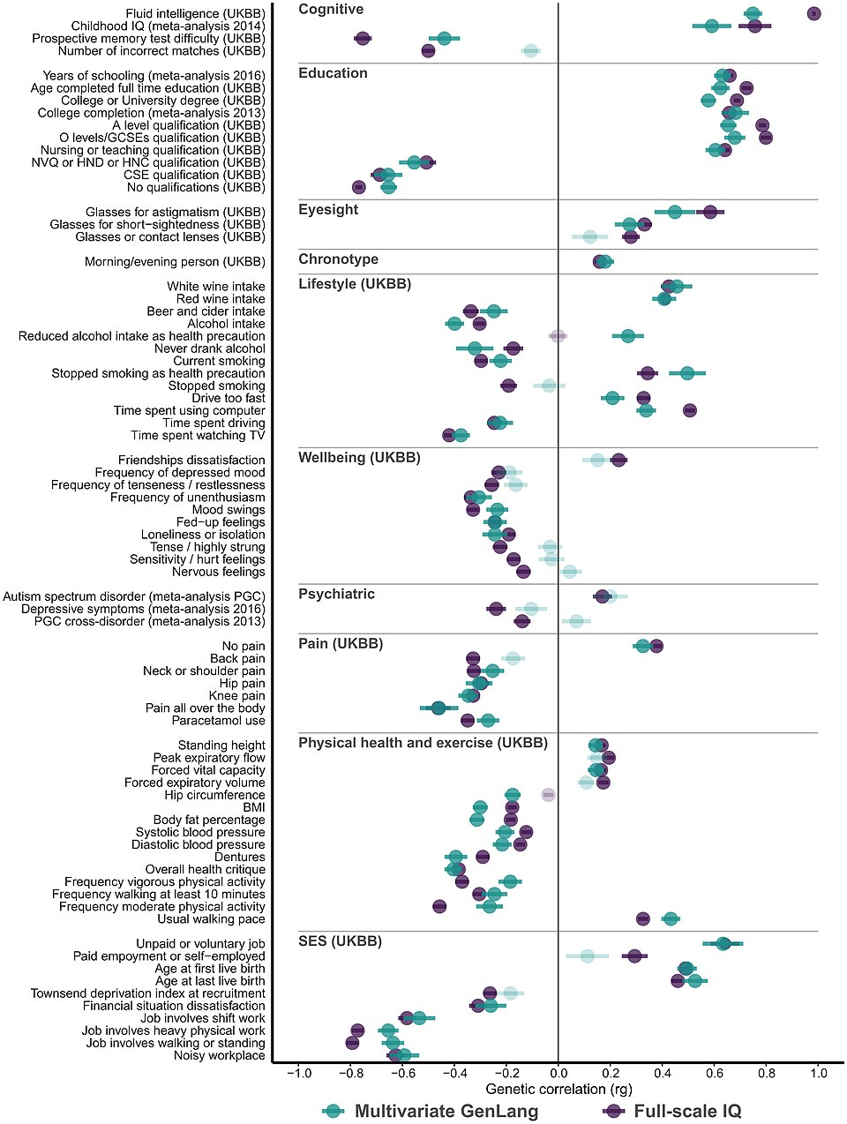
(2022, Eising et al.) Figure showing correlation between genetics and behavioural traits.
The presence of genetic correlations shows that nature is likely to play a role in our behavioural exhibitions, though it is uncertain to what extent. Evidence should be treated with discretion.

Born or made?
- The psychopaths
"A devil, a born devil, on whose nature Nurture can never stick"
-William Shakespeare, The Tempest (Act 4, Scene 1)
Psychopathy is a personality construct characterised by antisocial behaviours and is often a gateway into diagnoses such as antisocial personality disorder, narcissistic personality disorder, schizoaffective disorder, etc., having a high hereditary rate of up to 50% in severe cases . Once violent symptoms emerge, there’s little treatment and scarce success in rehabilitating affected persons, fuelling claims psychopaths are “made” into their callous personas. Being born, however, from a lineage with recurring psychopathy, doesn’t make it prophetic for the offspring. Neither do all psychopaths become criminals, regardless of predisposition, a corrective and kind upbringing could mitigate the potential for violence, suggesting epigenetics to be a plausible explanation for this. A poor temperament in infantry and childhood misdemeanour is unfortunately not easily explained through the means of upbringing (assuming the absence of ongoing abuse or trauma) though, as some evidence suggests psychopathic traits can appear as early as 2 years old. Additionally, diffusion tension imaging and functional magnetic imaging has shown the brain of a psychopath to have reduced connections between the prefrontal cortex and amygdala, lessening empathy and anxiety. This shows that in the case of severely disturbed behaviours, the extent of behavioural sculpting by a caregiver is not as influential.

- The anxious
“By this good light, this is a very shallow monster. I afeard of him! A very weak monster.”
-William Shakespeare, The Tempest (Act 2, Scene 2)
Phobias can isolate innate and learned behaviours, with them predominantly initiating during the critical period due to conditioning. Infants are born with two fears: falling and loud noises, which are exclusively survival based. They could also be born with separation anxiety, which can become a fear of the dark due to its association with being alone, but that is less unanimous. With age, many people learn to fear spiders, snakes, heights and other stimuli associated with danger. Some objects of fear might’ve appeared threatening at some point in childhood, like being stung by a bee or seeing your caregiver scream at the sight of a spider. Direct contact with a stimulus is not needed to develop a fear of them, the portrayal of them is crucial to the manifestation of it. As a child, the brain’s plasticity makes fears more readily obtainable, which also makes some fears easier to outgrow, but in the cases of trauma induced fears such as being attacked by a dog, it can be long lasting. The success of conquering fears can entirely depend on the individual; behaviours caused by phobias, such as avoidance, may be more persistent to those with a greater vulnerability to anxiety caused by inheritance.

The tendency to feel afraid is primal based on survival, which is the foundation of our brain’s functioning. Fear can then diverge to be specific, becoming normalised so fight or flight responses made to keep us safe start being used for several conditioned triggers. Antisocial behaviours, on the other hand, goes against alleged ‘pack mentality’ and humans being inherently pro social creatures, which, on the surface, seems to be at the fault of upbringing. But now that it is known some children are born lacking this sociability, it’s also nature. Whilst an inclination to harm or run from something that is a threat is innate, these behaviours are manipulable to not need a justifiable (or any) threat, by nature, or how we are treated during our most impressionable stages of life.

Idiosyncrasy in action
“What elicits a certain behaviour in one person is often very different from what elicits that same behaviour in another.” -Eysenck (1953), Forkosh et al., (2019)
Nature and nurture referred to in Latin would be “nasci” (“to be born”) and “nutrire” (“to nourish”). Historically, nature addresses the beginning and nurture follows; nurturing cannot occur without nature, likewise nature cannot blossom without nurturing. The intertwined existence of the words in general usage is heavily reflected from a psychological perspective, since using one without the other renders an explanation for behaviour mostly incomplete. Pavlov’s research into dogs looked into innate variables after the original experiment which coined classical conditioning, noting that despite it having consistent effectiveness, the amount of and timing of salivation was different, reflecting how people who have had similar conditioning will exhibit the response with slight variation due to nature. Considering the paralleled scenarios below, we can observe this:
A man spills a drink on Tom at a party. Instead of apologising, the man laughs and walks away. Tom begins to feel enraged, yelling at the man.
A man spills a drink on Eric at a party. Instead of apologising, the man laughs and walks away. Irritated, Eric gives the man a dirty look and scoffs.
In behavioural psychology, Tom and Eric could be assumed to have been conditioned to expect basic manners, such as apologising, for accidents like this, leading to the mutual feeling of anger. By nature’s standard, Tom’s behaviour could be caused by an imbalance of chemicals in the brain, which causes disproportionate and aggressive reactions, compared to Eric who has a healthier chemical balance, showing the reasoning behind the differing scaled responses. However, this can be rearranged, as perhaps it’s their nature which gave them a similar capacity to feel anger and their separate upbringings which influenced the extremity of it. Either way, nature and nurture are interactive, ignoring the effect of one makes the other a heavy weight-bearing factor for human behaviour, which is far too complex to accept a reductionist approach.

Conclusion
To some regard, upbringing will irrefutably have an impact on behaviour and the way we conduct ourselves. No type of childhood can truly be ubiquitous, so it is very likely it influences our varied behaviours. However, the strength of it seems to falter to high hereditary rates, as often, the pathogenic variants of genes passed down seem to be difficult to overcome even with wary upbringing, psychopathy outlined this circumstance particularly as did invisible disabilities like autism. It appears that prosocial traits are more easily swayed by their environment, conscious and unconscious, whereas those who have a total lack of regard for their place in society are more likely to be reduced to their nature. In their own respects, nature and upbringing are dependent on each other for producing behaviours in a systematic manner, it is only the strength of each that is subject to the individual.

Wikipedia Contributors (2019). Behavioural genetics. [online] Wikipedia. Available at: https://en.wikipedia.org/wiki/Behavioural_genetics.
Turkheimer, E. (2000). Three Laws of Behavior Genetics and What They Mean. Current Directions in Psychological Science. 9(5), pp.160–164. doi:https://doi.org/10.1111/1467-8721.00084.
Chabris, C.F., Lee, J.J., Cesarini, D., Benjamin, D.J. and Laibson, D.I. (2015). The Fourth Law of Behavior Genetics. Current Directions in Psychological Science. [online] 24(4), pp.304–312. doi:https://doi.org/10.1177/0963721415580430
Ozaki, N., Goldman, D., Kaye, W.H., Plotnicov, K., Greenberg, B.D., Lappalainen, J., Rudnick, G. and Murphy, D.L. (2003). Serotonin transporter missense mutation associated with a complex neuropsychiatric phenotype. Molecular Psychiatry. 8(11), pp.933–936. doi:https://doi.org/10.1038/sj.mp.4001365.
Pooley, E.C., Fineberg, N. and Harrison, P.J. (2007). The met158 allele of catechol-O-methyltransferase (COMT) is associated with obsessive-compulsive disorder in men: case–control study and meta-analysis. Molecular Psychiatry. [online] 12(6), pp.556–561. doi:https://doi.org/10.1038/sj.mp.4001951.
Kety, S.S., Rosenthal, D., Wender, P.H., Schulsinger, F. and Jacobsen, B. (1976). Mental illness in the biological and adoptive families of adopted individuals who have become schizophrenic. Behavior Genetics. 6(3), pp.219–225. doi:https://doi.org/10.1007/bf01065721.
Wikipedia. (2022). De novo mutation. [online] Available at: https://en.wikipedia.org/wiki/De_novo_mutation.
Wikipedia Contributors (2025). De novo gene birth. [online] Available at: https://en.wikipedia.org/wiki/De_novo_gene_birth
Pande, S., Majethia, P., Nair, K., Rao, L.P., Mascarenhas, S., Kaur, N., do Rosario, M.C., Neethukrishna, K., Chaurasia, A., Hunakunti, B., Jadhav, N., Xavier, S., Kumar, J., Bhat, V., Bhavani, G.S., Narayanan, D.L., Yatheesha, B.L., Patil, S.J., Nampoothiri, S. and Kamath, N. (2023). De novo variants underlying monogenic syndromes with intellectual disability in a neurodevelopmental cohort from India. European Journal of Human Genetics, [online] 32(10), pp.1291–1298. doi:https://doi.org/10.1038/s41431-023-01513-7.
Yoon, S., Munoz, A., Yamrom, B., Lee, Y., Andrews, P., Marks, S., Wang, Z., Reeves, C., Winterkorn, L., Krieger, A.M., Buja, A., Pradhan, K., Ronemus, M., Baldwin, K.K., Levy, D., Wigler, M. and Iossifov, I. (2021). Rates of contributory de novo mutation in high and low-risk autism families. Communications Biology. 4(1). doi: https://doi.org/10.1038/s42003-021-02533-z.
Diagnostic and Statistical Manual of Mental Disorders-Fifth edition. (2013). Autism spectrum disorder criteria. [online] Available at: https://pmc.ncbi.nlm.nih.gov/articles/PMC6713264/table/T2/.
New Scientist staff and Press Association (2019). Found: more than 500 genes that are linked to intelligence. [online] New Scientist. Available at: https://www.newscientist.com/article/2163484-found-more-than-500-genes-that-are-linked-to-intelligence/.
Wikipedia Contributors (2019). Psychopathy. [online] Wikipedia. Available at: https://en.wikipedia.org/wiki/Psychopathy.
Tiihonen, J., Koskuvi, M., Lähteenvuo, M., Virtanen, P.L.J., Ojansuu, I., Vaurio, O., Gao, Y., Hyötyläinen, I., Puttonen, K.A., Repo-Tiihonen, E., Paunio, T., Rautiainen, M.-R., Tyni, S., Koistinaho, J. and Lehtonen, Š. (2019). Neurobiological roots of psychopathy. Molecular Psychiatry. [online] 25. doi:https://doi.org/10.1038/s41380-019-0488-z.
Psychology Today. (2016). How Early Can We Identify Psychopathy in a Child? [online] Available at: https://www.psychologytoday.com/gb/blog/fulfillment-at-any-age/201611/how-early-can-we-identify-psychopathy-in-a-child.
University of Wisconsin-Madison (2017). Psychopaths’ Brains Show Differences in Structure and Function. [online] School of Medicine and Public Health. Available at: https://www.med.wisc.edu/news/psychopaths-brains-differences-structure-function/. ‌
Anon. (2021). Is Fear Learned or Innate?. Future-Edge Therapy. [online] Available at: https://www.future-edgetherapy.co.uk/is-fear-learned-or-innate/.
Wikipedia Contributors (2026). Fear of the dark. Wikipedia. [online] Available at: https://en.wikipedia.org/wiki/Fear_of_the_dark
londongenetics.co.uk. (2025). London Genetics. [online] Available at: https://londongenetics.co.uk/genetic-wellness-lifestyle/health-genetic-insights/
Adams, M. (2020). The kingdom of dogs - The British Psychological Society. [online] www.bps.org.uk. Available at: https://www.bps.org.uk/psychologist/kingdom-dogs.

